**1. Federal Deposit Insurance Corporation (FDIC)**

**2. Office of the Comptroller of the Currency (OCC)**

**3. Federal Reserve System**

**(Presented By Alan Stuart K)**

**1. Federal Deposit Insurance Corporation (FDIC):**

**Introduction:**

The Federal Deposit Insurance Corporation (FDIC) plays a crucial role in maintaining stability and public confidence in the US financial system by insuring deposits at banks and thrift institutions. The total assets held by FDIC-insured institutions have grown significantly over the past two decades. In 2000, total assets stood at $6.92 trillion, increasing steadily to $24.05 trillion by 2023. This growth reflects the expansion of the banking sector, increased savings, and broader economic growth.

**Key Observations:**

* **2008 Financial Crisis:** A significant jump in total assets from $11.20 trillion in 2007 to $13.78 trillion in 2008, partly due to regulatory responses and bank consolidations.
* **Post-2008 Recovery:** Continued growth in assets, reflecting recovery efforts and economic expansion.
* **COVID-19 Pandemic:** An increase to $21.77 trillion in 2020, indicating heightened saving rates and economic stimulus measures.

**Graphs:**

**Graph 1.A**: Number of FDIC-Insured Institutions (2000-2023):

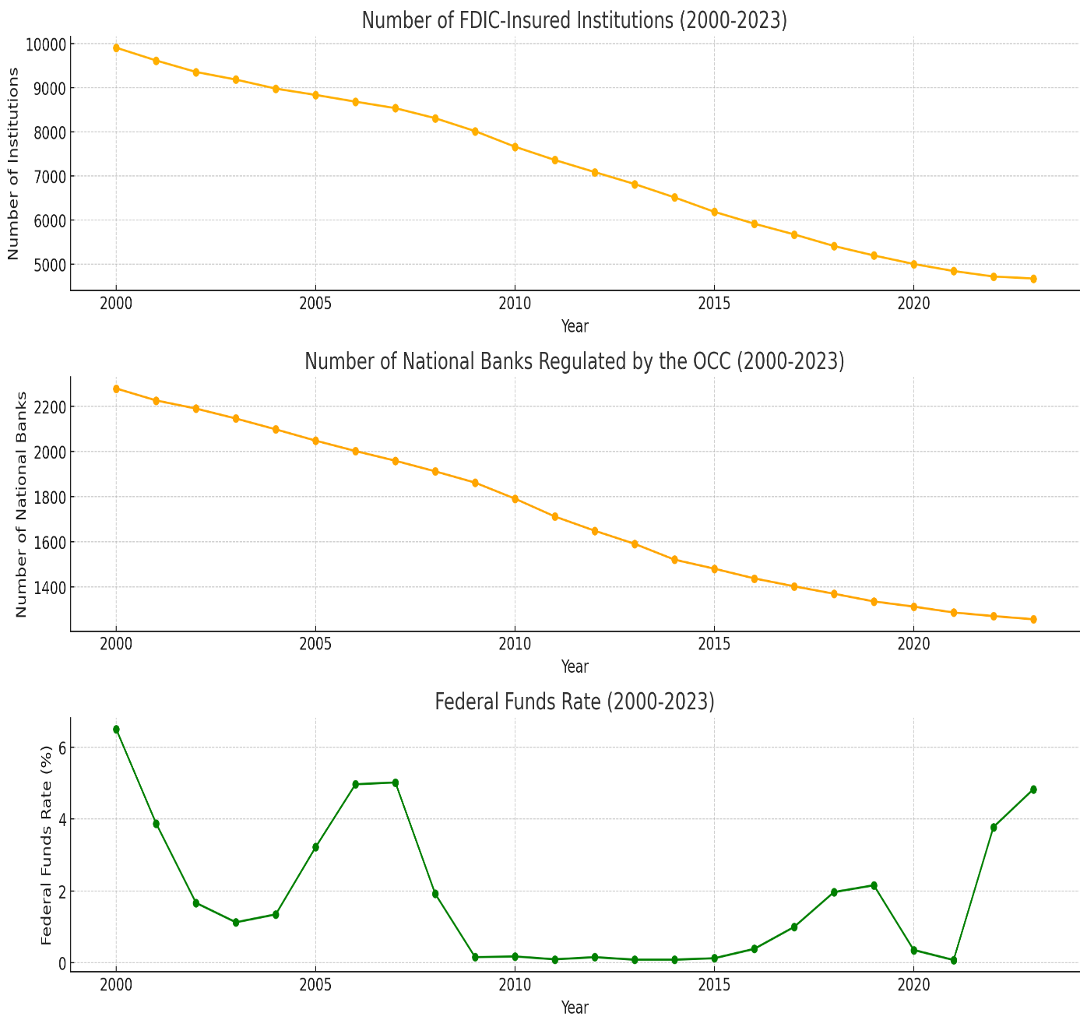

* **Trend**: The number of FDIC-insured institutions has been steadily declining from 2000 to 2023.
* **Inference**: The reduction in the number of FDIC-insured institutions suggests a consolidation trend within the banking industry, likely due to mergers, acquisitions, and closures. This could indicate efforts to improve efficiency and reduce competition among smaller banks.

**Graph 1.B**: Total Assets of FDIC-Insured Institutions (2000-2023):

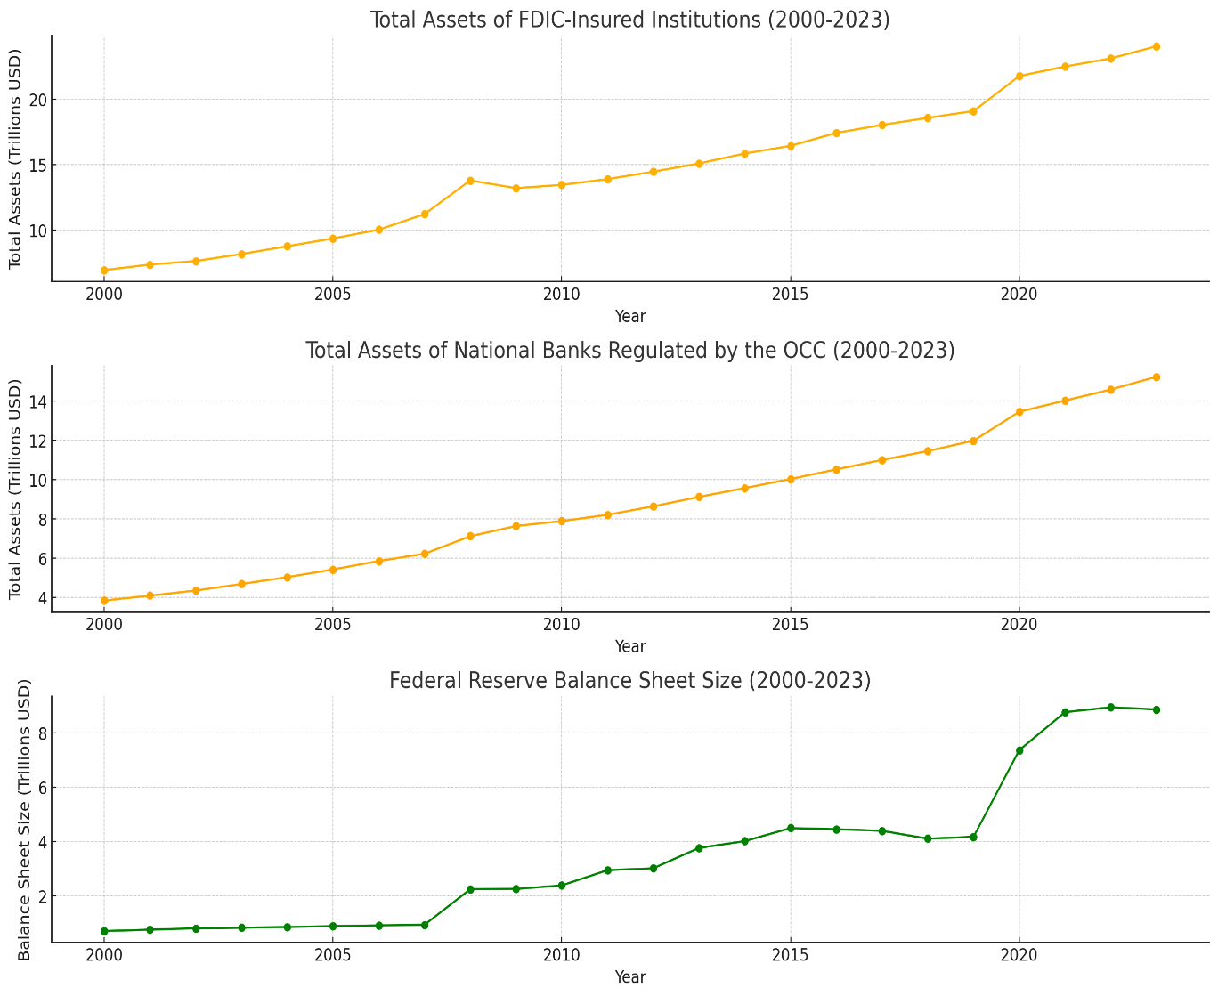

* **Trend**: The total assets of FDIC-insured institutions have increased significantly over the period from 2000 to 2023, with notable jumps during and after the 2008 financial crisis.
* **Inference**: The growth in total assets suggests that while the number of institutions has decreased, the remaining institutions have grown larger. This reflects industry consolidation and possibly increased market share and asset accumulation by the surviving banks.

**Graph 1.C**: Non-Current Loans and Leases as a Percentage of Total Loans and Leases (2000-2023):

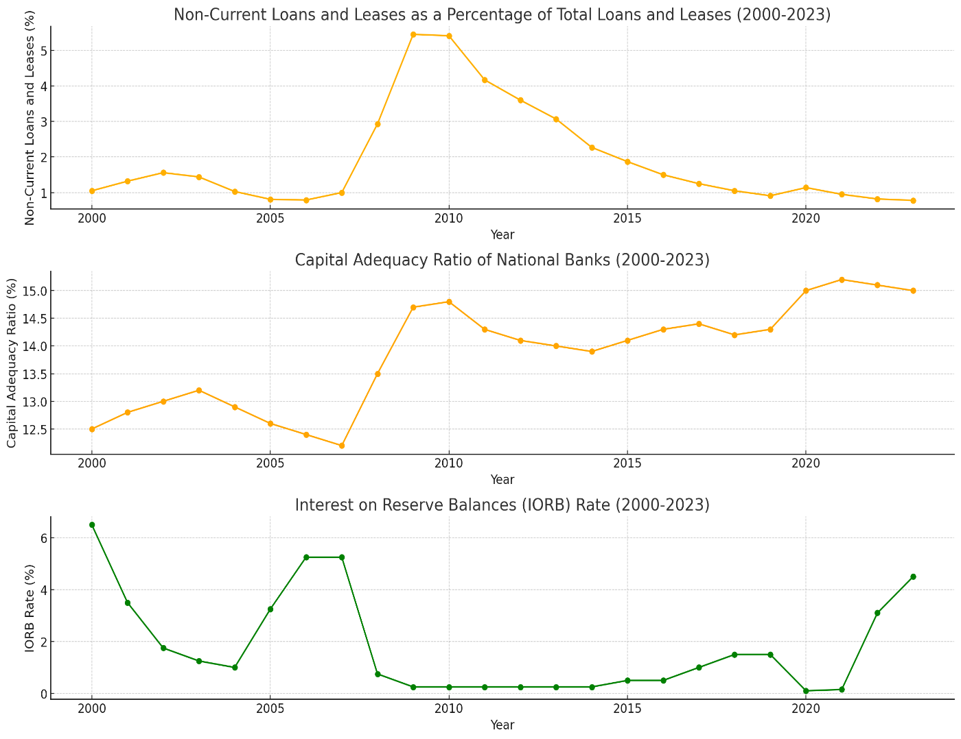

* **Trend**: The percentage of non-current loans and leases peaked around 2009 during the financial crisis and has since been declining, reaching low levels in recent years.
* **Inference**: The sharp increase during the financial crisis reflects the rise in loan defaults and credit issues faced by banks. The subsequent decline indicates improved loan performance and stronger credit quality within FDIC-insured institutions.

**2. Office of the Comptroller of the Currency (OCC):**

**Introduction:**

The Office of the Comptroller of the Currency (OCC) regulates and supervises national banks and federal savings associations. The capital adequacy ratio (CAR) is a key metric reflecting the financial health and resilience of these institutions. From 2000 to 2023, national banks have significantly improved their capital positions, with CAR increasing from 12.50% to 15.00%.

**Key Observations:**

* **Pre-Crisis Period:** Stable CAR around 12-13% before the 2008 financial crisis.
* **Post-Crisis Strengthening:** Increased CAR, peaking at 15.20% in 2021, due to stricter regulatory requirements and improved risk management.
* **Resilience:** The maintained high CAR in recent years shows continued robustness in capital adequacy, enhancing the sector's ability to withstand economic shocks.

**Graphs:**

**Graph 2.A**: Number of National Banks Regulated by the OCC (2000-2023):

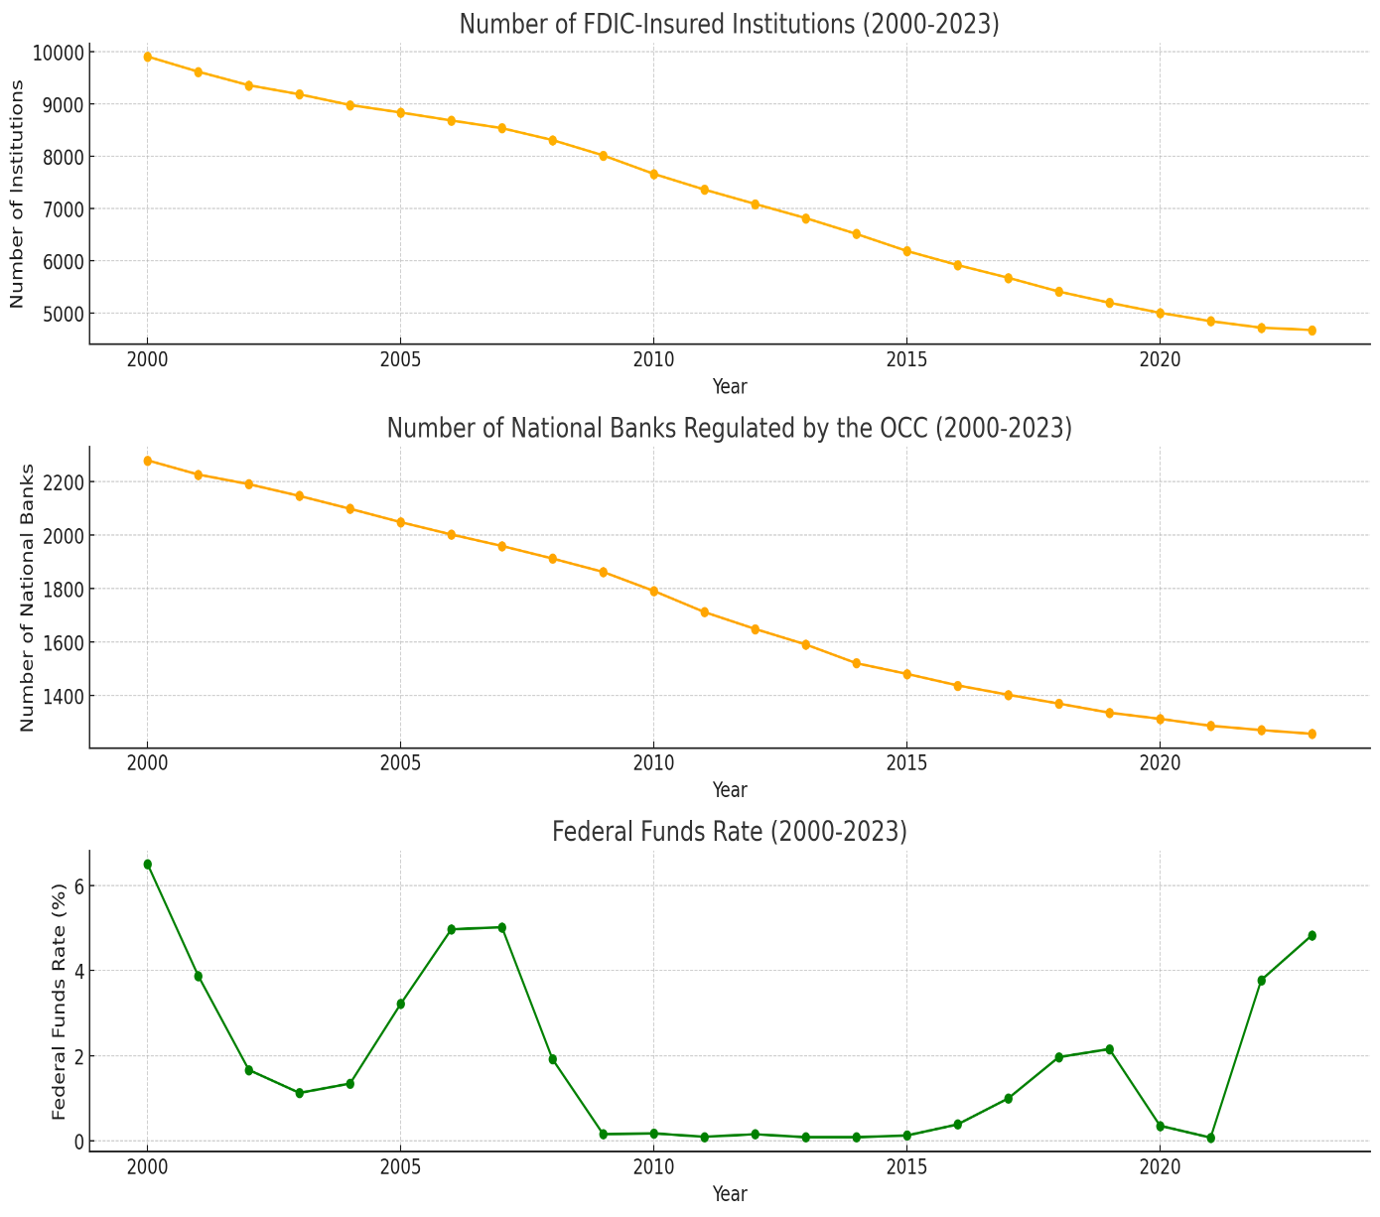

* **Trend**: Similar to the FDIC data, the number of national banks regulated by the OCC has also been declining over the same period.
* **Inference**: The decrease in the number of national banks indicates a consolidation within the sector, with many banks either merging or converting to state-chartered institutions. This trend reflects a broader shift in the banking industry towards larger, more consolidated entities.

**Graph 2.B**: Total Assets of National Banks Regulated by the OCC (2000-2023):

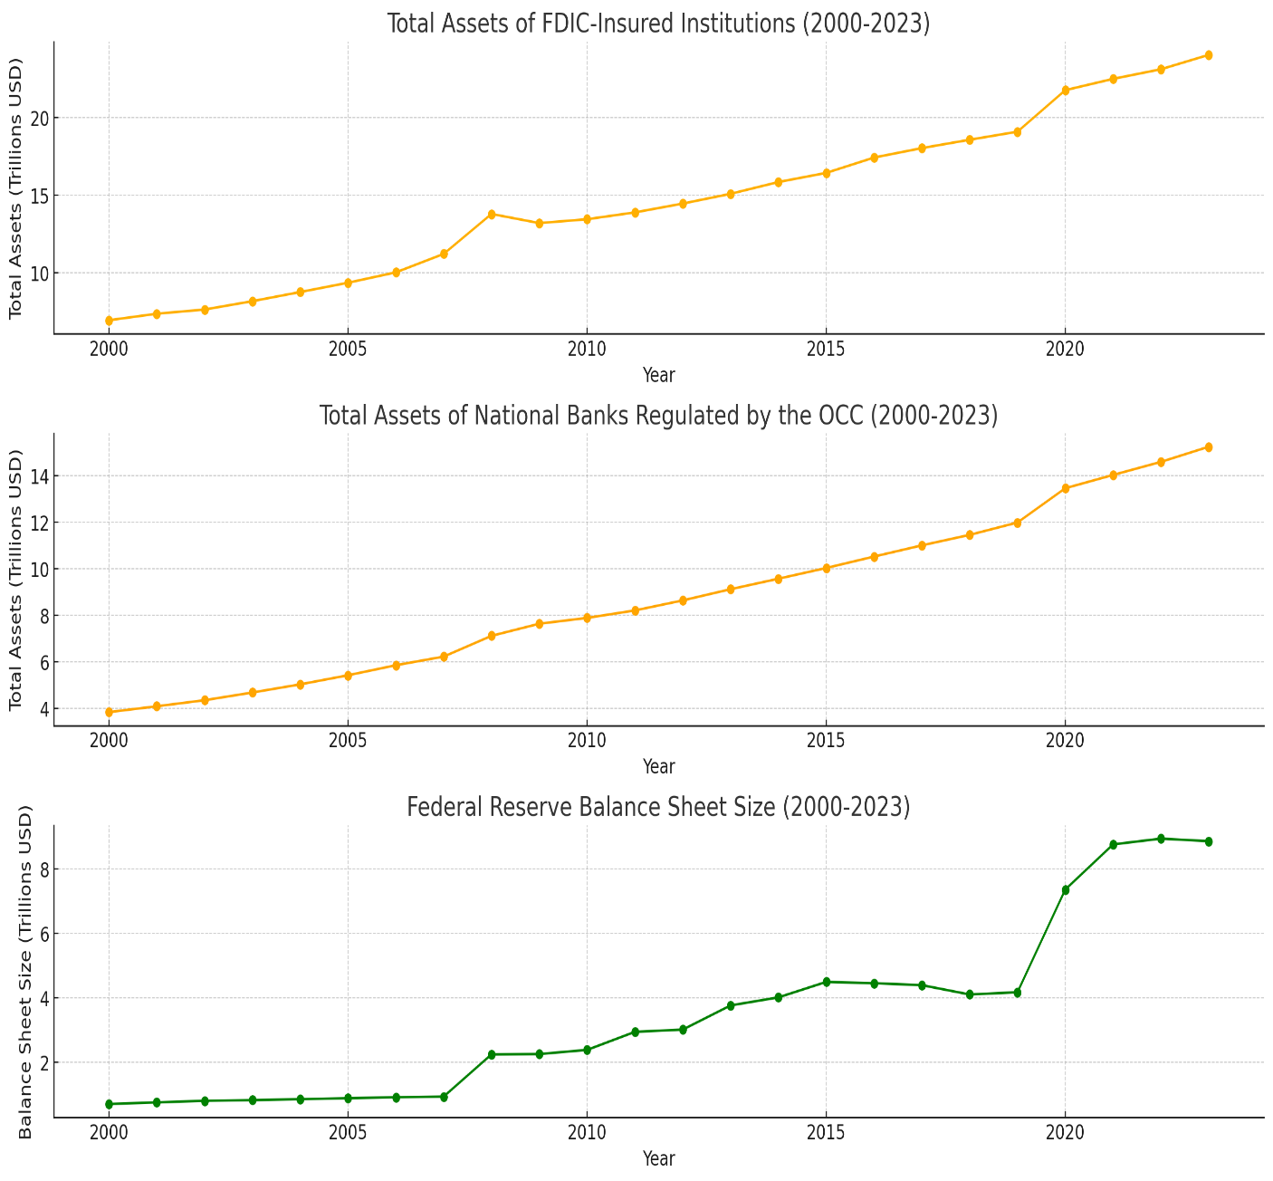

* **Trend**: The total assets of national banks regulated by the OCC have also shown a significant increase over the same period, following a similar pattern to the FDIC data.
* **Inference**: This trend supports the idea of consolidation within the banking sector, with national banks accumulating more assets and growing in size. It indicates that national banks are playing a larger role in the financial system over time.

**Graph 2.C**: Capital Adequacy Ratio of National Banks (2000-2023):

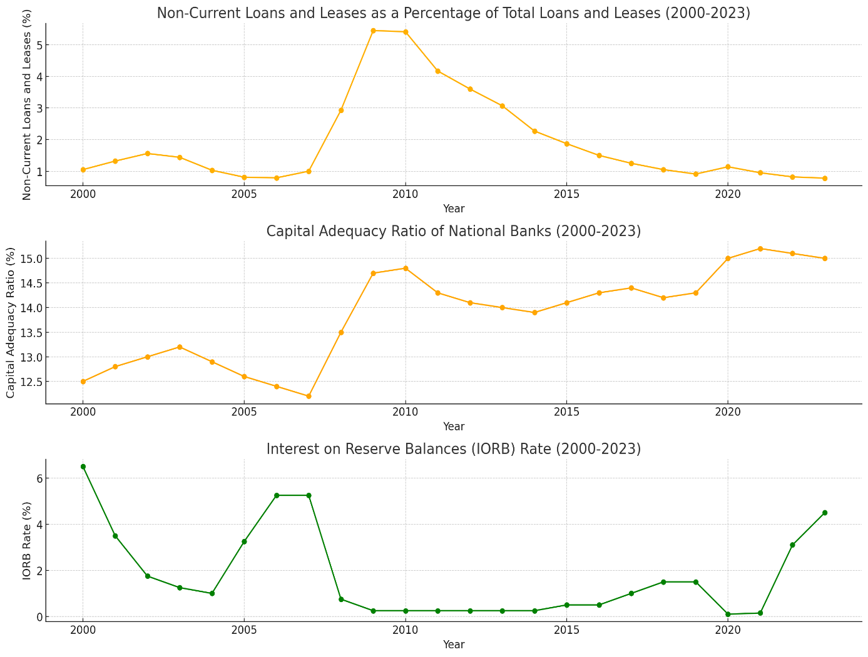

* **Trend**: The capital adequacy ratio (CAR) of national banks has generally been increasing since the financial crisis of 2008, peaking in recent years.
* **Inference**: The increase in CAR indicates that national banks have been strengthening their capital positions, improving their ability to absorb potential losses. This is likely a response to regulatory changes and a focus on financial stability post-crisis.

**3. Federal Reserve System:**

**Introduction:**

The Federal Reserve System (Fed) is the central bank of the United States, responsible for monetary policy, financial stability, and banking supervision. The size of the Fed's balance sheet and the Interest on Reserve Balances (IORB) rate are crucial indicators of its monetary policy stance.

**Balance Sheet Size:** The Fed's balance sheet expanded dramatically following the 2008 financial crisis and the COVID-19 pandemic, reflecting quantitative easing (QE) measures aimed at stabilizing the economy. The balance sheet size grew from $0.70 trillion in 2000 to $8.86 trillion in 2023.

**Key Observations:**

* **2008 Financial Crisis:** Sharp increase in balance sheet size due to QE, reaching $2.24 trillion in 2008.
* **COVID-19 Pandemic:** Another significant increase, peaking at $8.94 trillion in 2022, indicating extensive asset purchases to support the economy.

**Interest on Reserve Balances (IORB) Rate:** The IORB rate, a tool for influencing bank reserves and overall monetary policy, has varied significantly. It was high before 2008, dropped to near-zero post-crisis, and has increased recently to combat inflation.

**Key Observations:**

* **Pre-2008:** High rates (around 5-6%) aimed at controlling inflation and economic activity.
* **Post-2008:** Near-zero rates (0.25%) to stimulate economic growth.
* **Recent Trends:** Increased to 4.50% in 2023, reflecting tightening monetary policy to address rising inflation.

**Graphs:**

**Graph 3.A**: Federal Funds Rate (2000-2023):

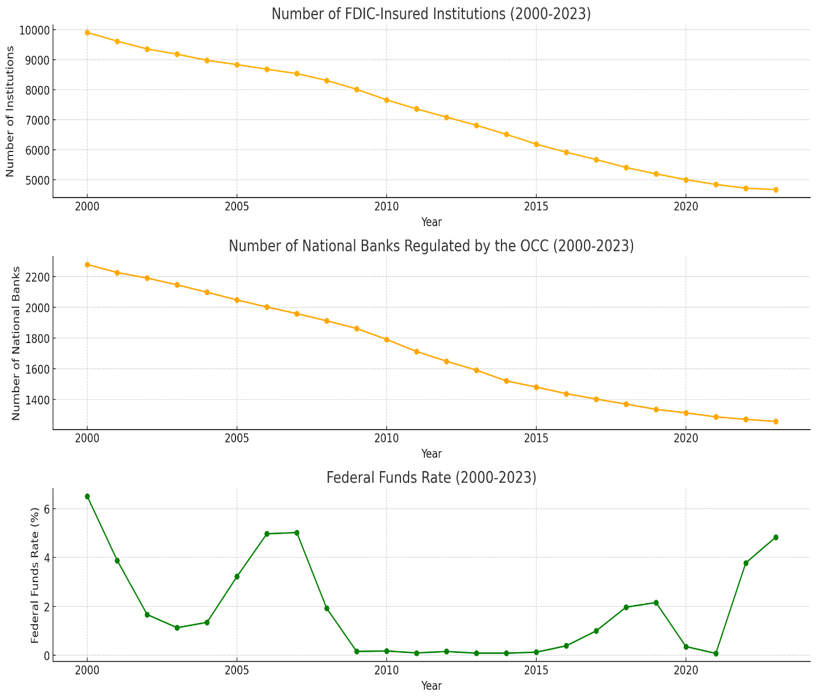

* **Trend**: The federal funds rate has experienced significant fluctuations over the years, with notable peaks in the early 2000s and mid-2000s, a sharp decline during the 2008 financial crisis, and a gradual increase in recent years.
* **Inference**: The fluctuations in the federal funds rate reflect the Federal Reserve's monetary policy responses to various economic conditions, including inflation, recession, and economic recovery. The low rates post-2008 were aimed at stimulating the economy, while the recent increases suggest efforts to control inflation and stabilize the economy.

**Graph 3.B**: Federal Reserve Balance Sheet Size (2000-2023):

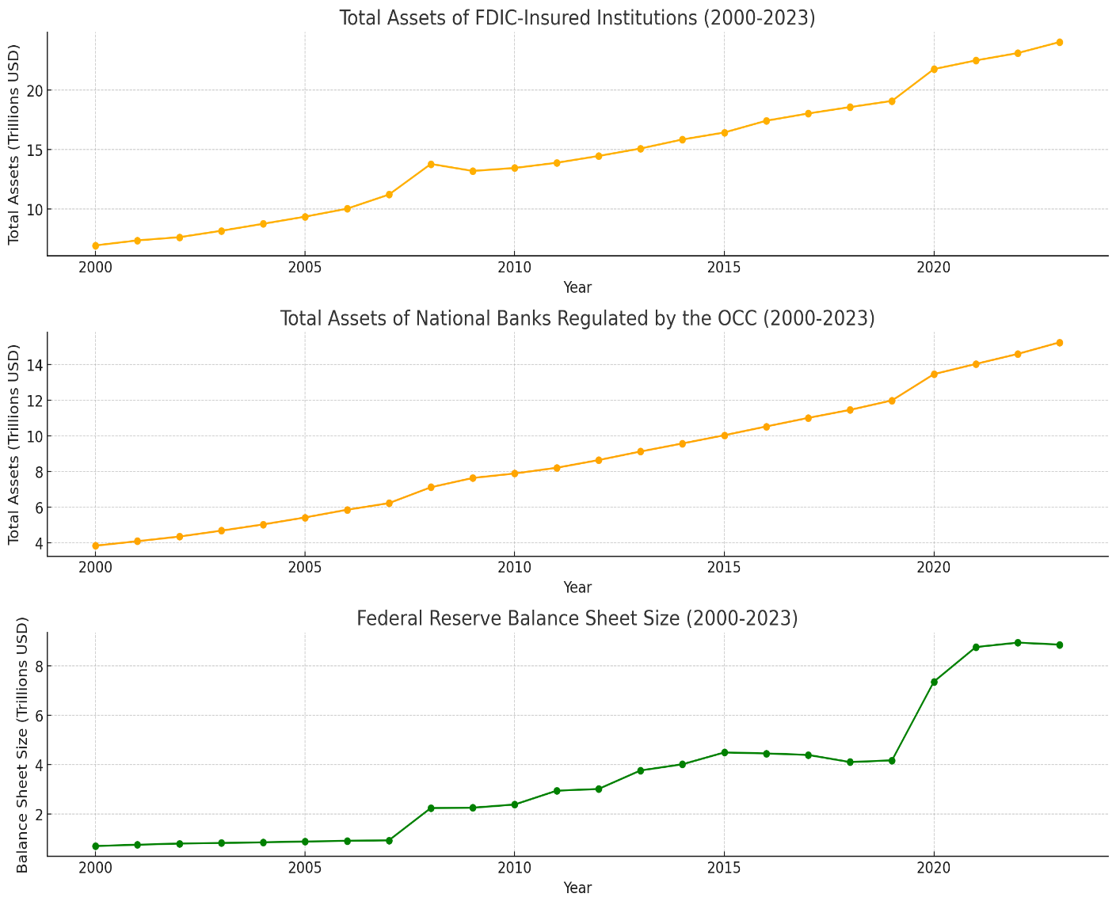

* **Trend**: The size of the Federal Reserve's balance sheet increased dramatically starting in 2008, peaking during the financial crisis and again during the COVID-19 pandemic.
* **Inference**: The sharp increases in the balance sheet size reflect the Federal Reserve's use of unconventional monetary policy tools such as quantitative easing (QE) to stabilize the economy during financial crises. The expansion of the balance sheet is indicative of the Fed's efforts to inject liquidity into the economy and support financial markets.

**Graph 3.C**: Interest on Reserve Balances (IORB) Rate (2000-2023):

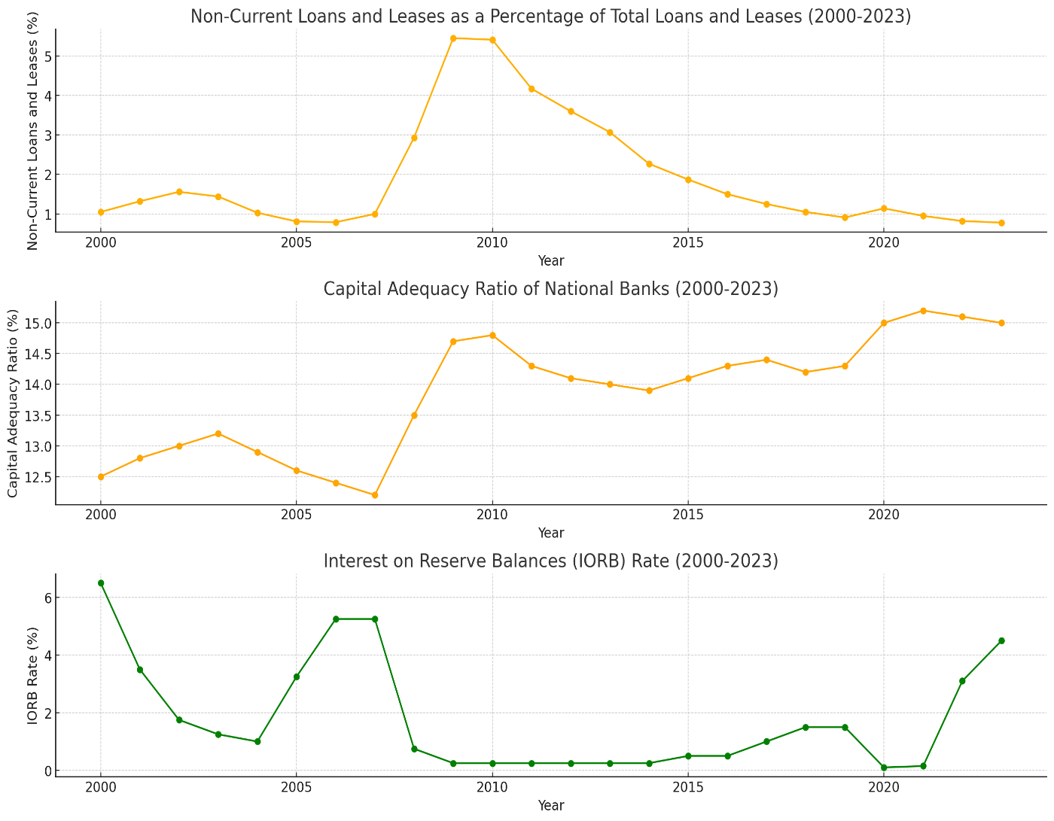

* **Trend**: The IORB rate shows significant fluctuations, with high rates before the 2008 crisis, very low rates post-crisis and during the COVID-19 pandemic, and a substantial increase in recent years.
* **Inference**: The variations in the IORB rate reflect the Federal Reserve's monetary policy adjustments aimed at influencing bank reserves and overall economic conditions. The low rates post-2008 and during COVID-19 were intended to stimulate the economy, while the recent increases suggest efforts to curb inflation and normalize monetary policy.

**Summary:**

Overall, these insights highlight the significant measures taken by US financial regulatory bodies to ensure the stability and robustness of the banking sector. The FDIC’s growth in total assets reflects economic expansion and increased savings. The OCC’s improved capital adequacy ratios underscore stronger financial health among national banks. Lastly, the Federal Reserve’s balance sheet expansion and fluctuating IORB rates demonstrate active monetary policy adjustments in response to economic conditions. These efforts collectively contribute to a resilient and well-regulated banking system in the United States.